**Mr. Visca’s**

**Algebra 2 Regents**

**THE COURSE**

The content standards associated with Algebra II are based on the New York State Common Core Learning Standards for Mathematics and the PARCC Model Content Framework for Algebra II. The content standards define what students should understand and be able to do at the high school level; the Model Content Framework describes which content is included and emphasized within the Algebra II course, specifically. For high school mathematics, the standards are organized at three levels: conceptual categories, domains and clusters. Algebra II is associated with high school content standards within five conceptual categories: Number & Quantity, Algebra, Functions, Geometry and Statistics & Probability. Each conceptual category contains domains of related clusters of standards. **THERE IS A REGENTS/COMMON CORE STATE EXAM IN JUNE!!!**

**BEHAVIOR**

All students should respect other students and the teacher. I also explain to students that the teacher must respect the students as well. It is a two way street, and that is critical to building a great relationship which is a must for anyone to learn effectively from their teacher. I find that the word “respect” covers almost every aspect: language, attitude, behavior, actions, completing work, following rules, being polite, etc… After all…we are all CREW, not passengers!

GRADING

Homework – 10%

Binder - 10%

Classwork – 20%

Quiz – 20%

Tests - 40%

CONTACT INFORMATION

School Phone #: 585-325-6170, ext. 1060

Email: [frank.visca@rcsdk12.org](mailto:frank.visca@rcsdk12.org) ** I prefer email

Website: [www.rcsdk12.org/58/visca](http://www.rcsdk12.org/58/visca) (students can get missing assignments and notes here)

STUDENT INFO FOR TEACHER: ***Please write so I can read it…thank you ☺***



Student Name: ____________________________________________

Parents Names: ___________________________________________

Parents Phone #(s): ________________________________________

Parents email(s): ____________________________________________________

**TECH PAGE!!!**

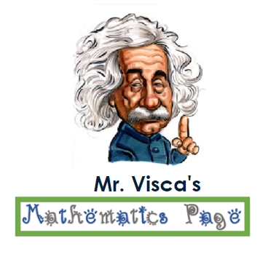

* **Watching Videos of lessons from class:** 
  + **my teacher site –** [www.rcsdk12.org/58/visca](http://www.rcsdk12.org/58/visca)
    - Just click the link (left side of page) of appropriate class you are in, and then scroll down to the class you want

OR

* [www.youtube.com/ViscaTheTeacher](http://www.youtube.com/ViscaTheTeacher)
  + I have a youtube channel, browse my videos, or do a search for class, like: “visca wois algebra 2 unit 3 lesson 4”



* **Sign up for REMIND**
  + Best Method, download the app
    - Download the mobile app for iOS and Android devices and create a new account (or log in if you already have one.) To join a class, tap the **+**by Classes Joined and either join with your class code, @alg2rv20, or search for your class. You'll automatically get app notifications
  + Join by Texting
    - Text @alg2rv20 to 81010
  + Join by PC (email)
    - Send a blank email to alg2rv20@mail.remind.com
* **I also have a twitter account**
  + @ViscaTheTeacher